ESP32 and Infrared receiver example

To connect an IR Reciever. Generally, they require Vcc(5v), GND and there is a data out which you connect to your Arduino. Here is a typical IR showing the pinout.

3.3v from the ESP32 board

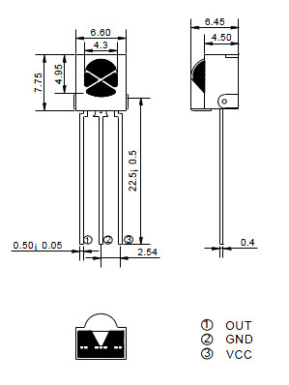

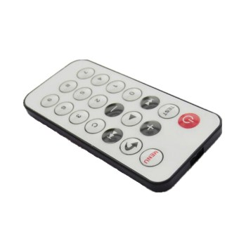

**Layout**

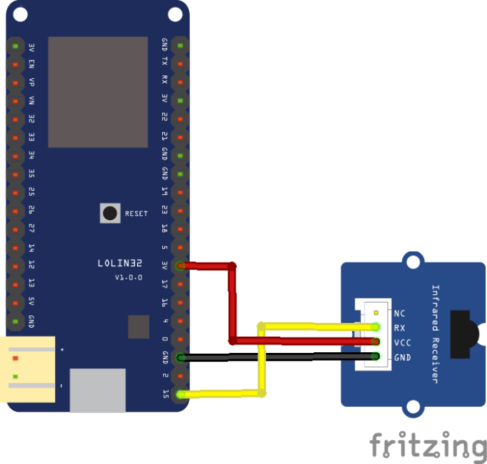

**Code**

You’ll need the IR Remote library, you can get this from

<https://github.com/shirriff/Arduino-IRremote>

Download and import or copy into your Arduino -> Library folder. As usual this library will be doing most of the work making it easier for ourselves.

#include <IRremote.h>

int RECV_PIN = 15;

IRrecv irrecv(RECV_PIN);

decode_results results;

void setup()

{

Serial.begin(9600);

irrecv.enableIRIn(); // Start the receiver

}

void loop()

{

if (irrecv.decode(&results))

{

Serial.println(results.value, HEX);

irrecv.resume();

}

}

**Testing**

I opened the serial monitor and pressed various keys on my remote here is what was displayed

FFA25D  
FFFFFFFF  
FFE21D  
FF22DD  
FFFFFFFF  
FF02FD  
FFFFFFFF  
FFC23D  
F076C13B  
FFFFFFFF  
FFA857  
FF906F  
FFFFFFFF  
FF6897  
FFFFFFFF  
FFFFFFFF  
FF9867  
FFFFFFFF  
FFB04F  
FFFFFFFF  
FF30CF

As you can see with a bit of programming we can take these values and put them to use.